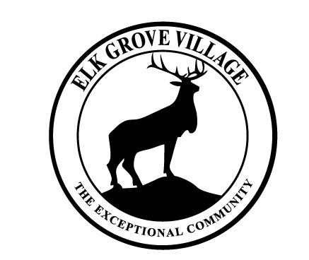

AGENDA

COMMITTEE OF THE WHOLE

**April 27, 2021**

**ROOM E**

**Following 4:00 PM Executive Session**

|  |
| --- |
| NEW BUSINESS |
| |  |  |  |  |  |  | | --- | --- | --- | --- | --- | --- | | 1. | Subject: | Drainage Assessment |  | Issue: | Consideration of a presentation on a proposed drainage assessment. | |  | Reference: | Presentation by the Village's drainage   consultant. |  |  | |